**CM1605 Web Technology**

**Tutorial 9**

The aim of this tutorial is to demonstrate the knowledge on XML well-formed rules, design a plain XML document and use CSS to improve the display of the XML output. Apply knowledge of the XML DOM model to access and manipulate data stored in XML documents.

This is an individual exercise. You may use any text editor (Notepad, Notepad ++) to create/modify the HTML pages and any Browser application (chrome, IE, firefox etc) to run the web pages.

**Part A**

Examine the following xml file. Identify all of its syntactical errors and write in the corrections.

a) Check for one root element.

b) Check for properly opened and closed element tags.

c) Check for case sensitive element naming.

d) Check for properly nested elements.

e) Check for quoted attribute values.

<name>Oyster Soup</name>

<author>Anne Oliver</author>

<ingredients>

<list>

<item ingredient=optional>1 stalk of celery

<item>1 onion

<item>2 tablespoons of butter

<item>2 cups of oysters and their liquor

<item>2 cups of milk

</list>

</ingredients>

<process>

<P>Begin by sauteing the celery and onions in butter until soft.

Add oysters, oyster liquor, and cream. Heat until the oysters float.

Serve in warm bowls.</p>

<p><i>Yummy!</p></i>

</process>

**Part B**

Write simple XML file to display the following information using CSS.

* A menu is made up of a heading followed by one or more sections;
* A heading is made up of a title and an address in any order;
* A section is made up of a subtitle followed by zero or more options;
* An option is made up of an item followed by a price;
* The following entries consist of plain text: title, address, subtitle, item, price.
* Note:
  + The title is "The Bar Cafe Menu".
  + The address is "New York – Harrow - Paris".

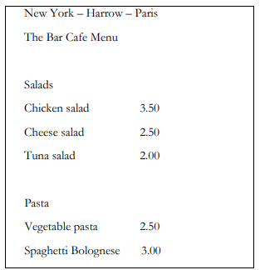

**Part C**

You need to generate the details of the following two books when the Get books button is clicked using JavaScript and XML Parser. Use the code snippets explained in the XML lecture note.

* The information of the books should be stored as plain XML.
* Read the XML data through the XML Parser and display the information in the html document using JavaScript.



